|  |
| --- |
| Dream Homes Realty Project Report  1.Project Introduction:  Introduction to the "Dream Homes Realty " project. Objectives and goals of the project  1.1 Project Overview  Dream Homes Realty are the very well planners. They construct a building and Furnshing to satisfy the customers needs.  1.2 purpose:  The purpose of dream homes Realty is to illustrate the decisions that made about designing the future dream house for the customers.It has to create a future dream for every customers.  2. Problem Definition and Design Thinking:  2.1 Empathy map |

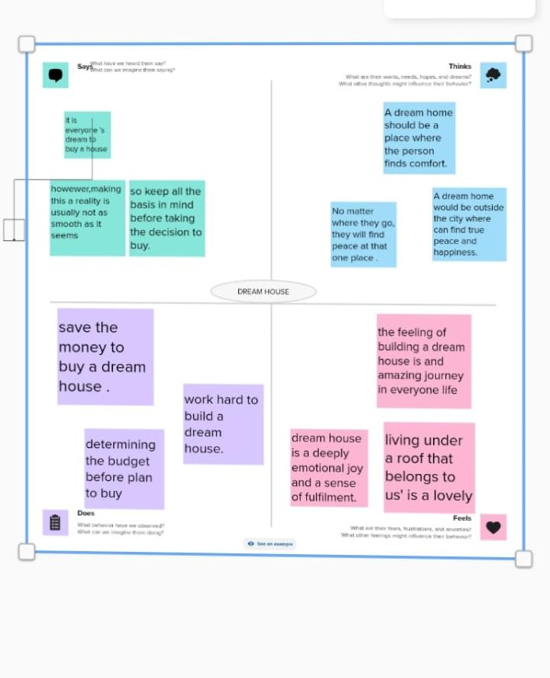

2.2 Ideation and Brainstrom

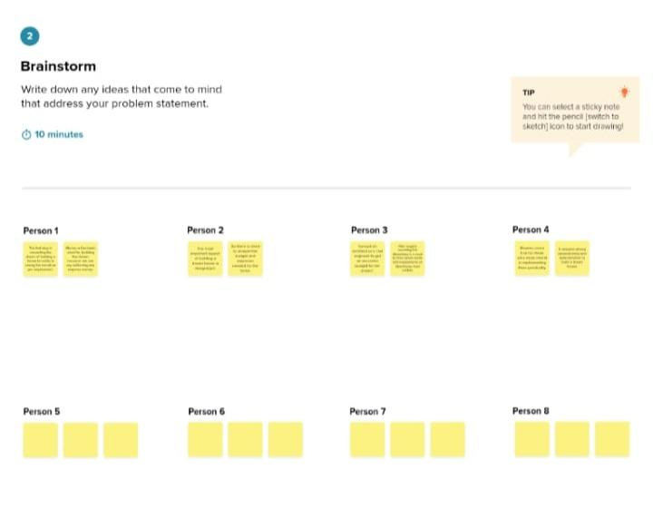

## 3.Result

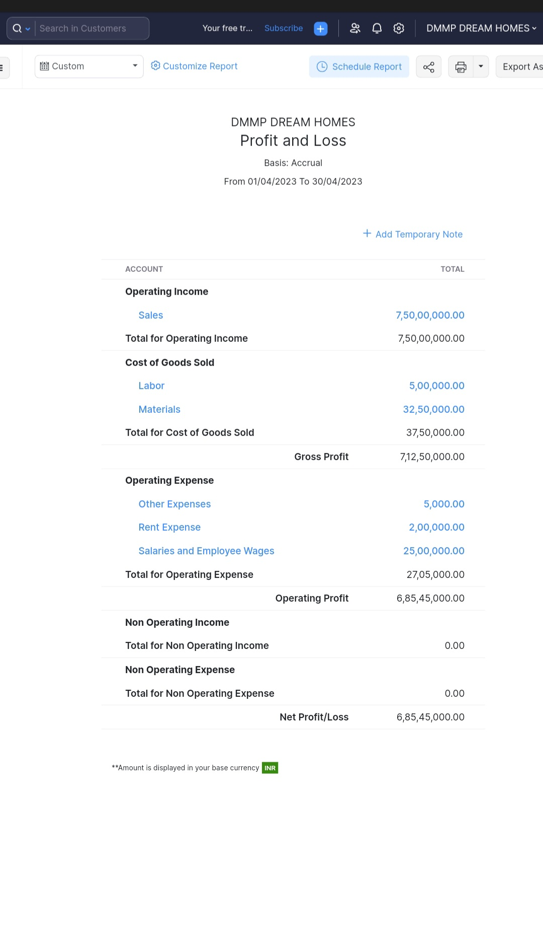

## 4.Advantages and Disadvantages:

## Advantages :

## 1.Building your dream house can be a long term investment, as it allows you to create a space that meets your needs now and in the future.

## 2.Owning a dream house that you have built from scratch can be a source of pride and satisfaction.

## 3. One of the most significant advantages of building your dream house is ability to customize every aspect of design to your liking.

## Disadvantages :

## 1. One of the most disadvantages is many people who buy houses end up tied to an expensive mortgage on a place they don’t not to mention the financial strain of a large upfront cost.

## 2.the most widely recognized disadvantage to purchasing an existing home is that it is likely not going to be the exact dream you’ve envisioned.

## 5.Applications:

## Dream Homes Realty:

## A dream house project could involve designing,landscaping,architecture elements that contribute to the overall atmosphere of the city.

## 6.conclusion:

## This program had been successfully executed.

## 7.future scope:

## Zoho development is going to focus on cloud service.

## 8.appendix:

## A.source code

## https://github.com/PREETHIPADEVI/Dream-House